Business Unit
Mobile Failures Report
ASAP 7.0.2 – JAMU66

Week 37
September 10th to September 16th, 2018

September 17th, 2018

Contents

1 Percentages for all mobile activations, changes and deactivations Anguilla 4
2 Percentages for all mobile activations, changes and deactivations Antigua 5
3 Percentages for all mobile activations, changes and deactivations Barbados 6
4 Percentages for all mobile activations, changes and deactivations British Virgin Islands 7
5 Percentages for all mobile activations, changes and deactivations Cayman 8
6 Percentages for all mobile activations, changes and deactivations Dominica 9
7 Percentages for all mobile activations, changes and deactivations Grenada 10
8 Percentages for all mobile activations, changes and deactivations Jamaica 11
9 Percentages for all mobile activations, changes and deactivations Monserrat 12
10 Percentages for all mobile activations, changes and deactivations Saint Vincent 13
11 Percentages for all mobile activations, changes and deactivations Turks and Caicos 14
12 Percentages for all mobile activations, changes and deactivations Santa Lucia 15
13 Percentages for all mobile activations, changes and deactivations Saint Kitts and Nevis 16
14 Top 5 failure issues Anguilla 17
15 Top 5 failure issues Antigua 17
16 Top 5 failure issues Barbados 17
17 Top 5 failure issues British Virgin Islands 18
18 Top 5 failure issues Cayman 18
19 Top 5 failure issues Dominica 18
20 Top 5 failure issues Grenada 19
21 Top 5 failure issues Jamaica 19
22 Top 5 failure issues Monserrat 19
23 Top 5 failure issues Saint Vincent 19
24 Top 5 failure issues Turks and Caicos 20
25 Top 5 failure issues Santa Lucia 20
26 Top 5 failure issues Saint Kitts and Nevis 20
27 Failure numbers Anguilla 21
28 Failure numbers Antigua 21
29 Failure numbers Barbados 22
30 Failure numbers British Virgin Islands 23
31 Failure numbers Cayman 23
32 Failure numbers Dominica 23
33 Failure Numbers Grenada 24
34 Failure numbers Jamaica 24
35 Failure numbers Monserrat 25
36 Failure numbers Saint Vincent 26
37 Failure numbers Turks and Caicos 26
38 Failure numbers Santa Lucia 27
39 Failure numbers Saint Kitts and Nevis 28

Percentages for all mobile activations, changes and deactivations Anguilla

 | TOTAL | COMPLETE | FAILED | % Total | % COMPLETE | % FAILED
ACTIVATE | 63 | 63 | 0 | 100% | 100% | 0%
DEACTIVATE | 0 | 0 | 0 | 0% | 100% | 0%
MODIFY | 0 | 0 | 0 | 0% | 100% | 0%

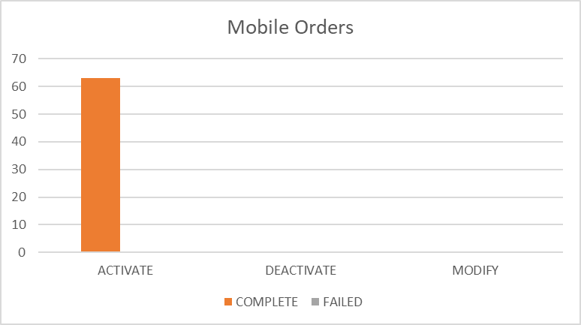

Percentages for all mobile activations, changes and deactivations Antigua

 | TOTAL | COMPLETE | FAILED | % Total | % COMPLETE | % FAILED
ACTIVATE | 63 | 56 | 7 | 4% | 89% | 11%
DEACTIVATE | 372 | 372 | 0 | 27% | 100% | 0%
MODIFY | 968 | 917 | 51 | 69% | 95% | 5%

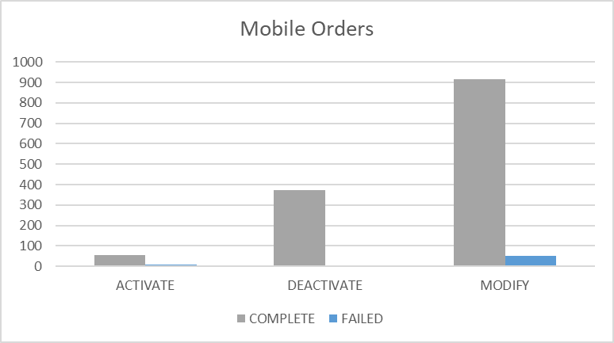

Percentages for all mobile activations, changes and deactivations Barbados

 | TOTAL | COMPLETE | FAILED | % Total | % COMPLETE | % FAILED
ACTIVATE | 34 | 26 | 8 | 2% | 76% | 24%
DEACTIVATE | 801 | 799 | 2 | 38% | 100% | 0%
MODIFY | 1247 | 1232 | 15 | 60% | 99% | 1%

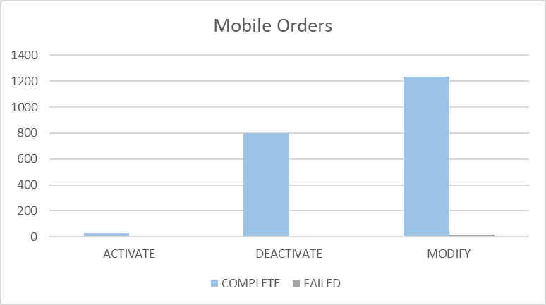

Percentages for all mobile activations, changes and deactivations British Virgin Islands

 | TOTAL | COMPLETE | FAILED | % Total | % COMPLETE | % FAILED
ACTIVATE | 109 | 109 | 0 | 10% | 100% | 0%
DEACTIVATE | 345 | 345 | 0 | 31% | 100% | 0%
MODIFY | 675 | 674 | 1 | 60% | 100% | 0%

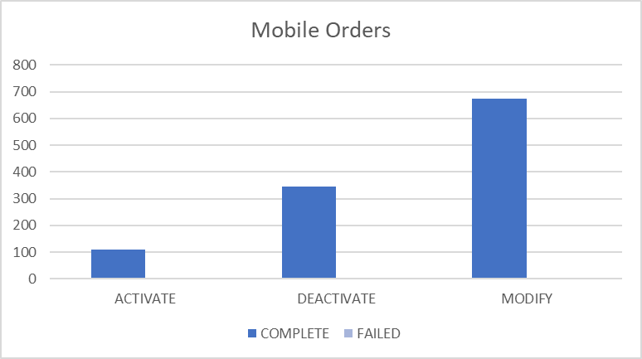

Percentages for all mobile activations, changes and deactivations Cayman

 | TOTAL | COMPLETE | FAILED | % Total | % COMPLETE | % FAILED
ACTIVATE | 73 | 72 | 1 | 7% | 99% | 1%
DEACTIVATE | 285 | 283 | 2 | 26% | 99% | 1%
MODIFY | 722 | 711 | 11 | 67% | 98% | 2%

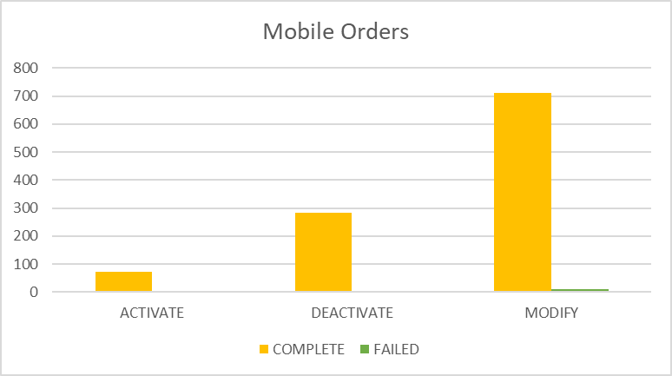

Percentages for all mobile activations, changes and deactivations Dominica

 | TOTAL | COMPLETE | FAILED | % Total | % COMPLETE | % FAILED
ACTIVATE | 3394 | 3382 | 12 | 42% | 100% | 0%
DEACTIVATE | 477 | 477 | 0 | 6% | 100% | 0%
MODIFY | 4151 | 4137 | 14 | 52% | 100% | 0%

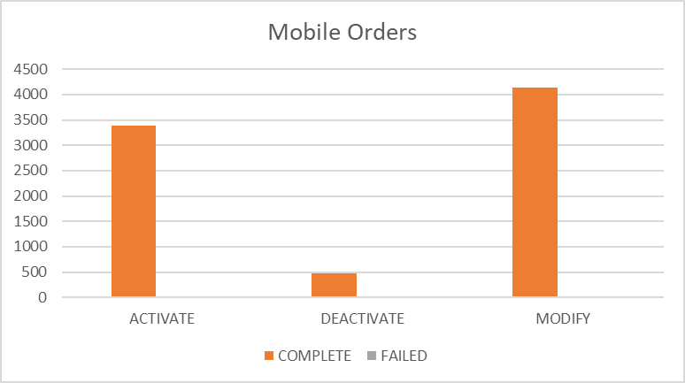

Percentages for all mobile activations, changes and deactivations Grenada

 | TOTAL | COMPLETE | FAILED | % Total | % COMPLETE | % FAILED
ACTIVATE | 279 | 279 | 0 | 19% | 100% | 0%
DEACTIVATE | 358 | 358 | 0 | 25% | 100% | 0%
MODIFY | 824 | 823 | 1 | 56% | 100% | 0%

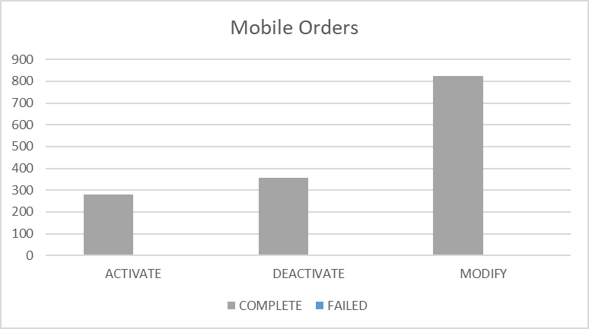

Percentages for all mobile activations, changes and deactivations Jamaica

 | TOTAL | COMPLETE | FAILED | % Total | % COMPLETE | % FAILED
ACTIVATE | 3417 | 3396 | 21 | 16% | 99% | 1%
DEACTIVATE | 4927 | 4926 | 1 | 23% | 100% | 0%
MODIFY | 13390 | 13339 | 51 | 62% | 100% | 0%

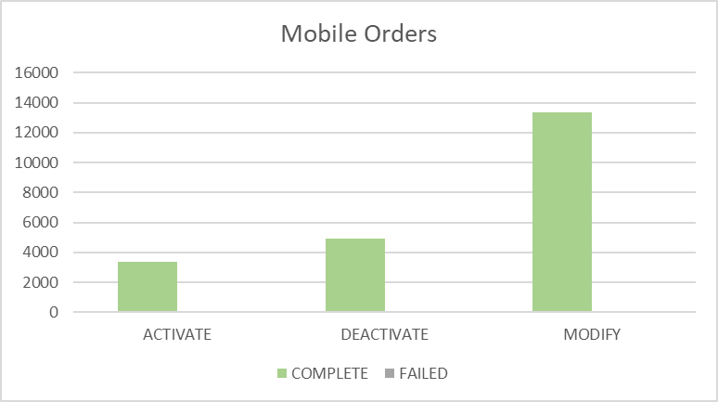

Percentages for all mobile activations, changes and deactivations Monserrat

 | TOTAL | COMPLETE | FAILED | % Total | % COMPLETE | % FAILED
ACTIVATE | 21 | 21 | 0 | 17% | 100% | 0%
DEACTIVATE | 29 | 29 | 0 | 24% | 100% | 0%
MODIFY | 71 | 71 | 0 | 59% | 100% | 0%

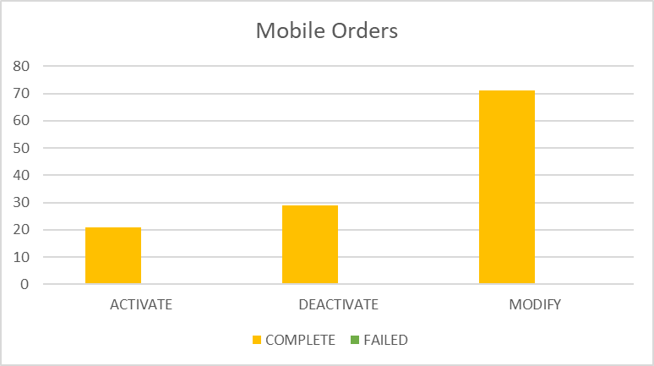

Percentages for all mobile activations, changes and deactivations Saint Vincent

 | TOTAL | COMPLETE | FAILED | % Total | % COMPLETE | % FAILED
ACTIVATE | 563 | 563 | 0 | 24% | 100% | 0%
DEACTIVATE | 420 | 420 | 0 | 18% | 100% | 0%
MODIFY | 1323 | 1321 | 2 | 57% | 100% | 0%

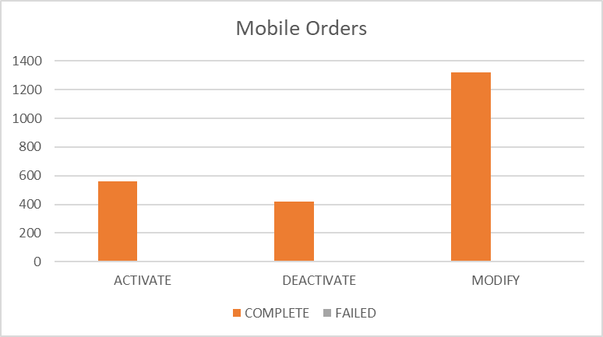

Percentages for all mobile activations, changes and deactivations Turks and Caicos

 | TOTAL | COMPLETE | FAILED | % Total | % COMPLETE | % FAILED
ACTIVATE | 154 | 146 | 8 | 10% | 95% | 5%
DEACTIVATE | 407 | 407 | 0 | 27% | 100% | 0%
MODIFY | 945 | 904 | 41 | 63% | 96% | 4%

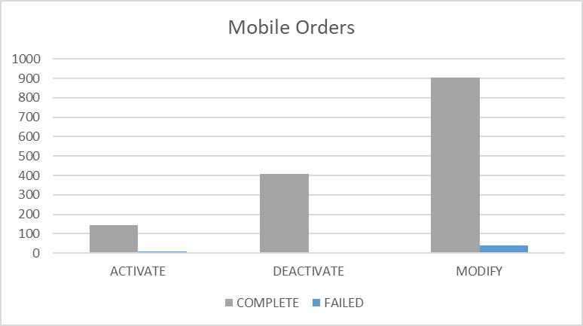

Percentages for all mobile activations, changes and deactivations Santa Lucia

 | TOTAL | COMPLETE | FAILED | % Total | % COMPLETE | % FAILED
ACTIVATE | 487 | 467 | 20 | 21% | 96% | 4%
DEACTIVATE | 427 | 427 | 0 | 18% | 100% | 0%
MODIFY | 1450 | 1425 | 25 | 61% | 98% | 2%

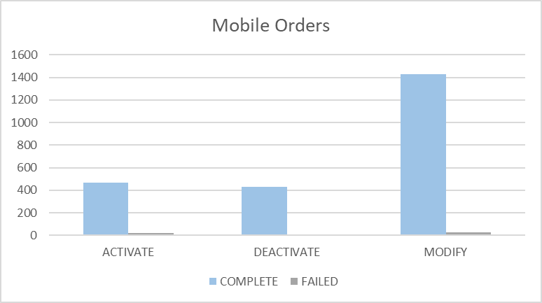

Percentages for all mobile activations, changes and deactivations Saint Kitts and Nevis

 | TOTAL | COMPLETE | FAILED | % Total | % COMPLETE | % FAILED
ACTIVATE | 198 | 193 | 5 | 17% | 97% | 3%
DEACTIVATE | 272 | 272 | 0 | 23% | 100% | 0%
MODIFY | 703 | 698 | 5 | 60% | 99% | 1%

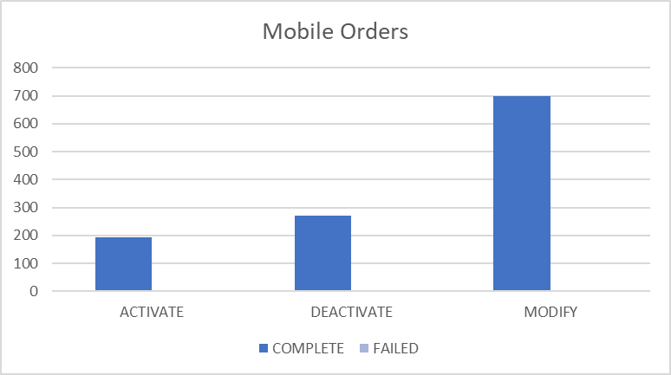

Top 5 failure issues Anguilla

NO ROWS SELECTED

Top 5 failure issues Antigua

AMOUNT | USER EXIT TYPES
20 | EMA_RESP_35101:Missing or invalid parameter.
13 | EMA_MISS_REQ_PARAM:Mandatory parameter is missing from work order
7 | EMA_RESP_1:The Specified IMSI is already defined
5 | EMA_RESP_14:The Specified MSISDN is not defined
3 | EMA_RESP_35105:The subscriber already exists.
3 | EMA_RESP_2:The Specified MSISDN is already defined with a different IMSI

Top 5 failure issues Barbados

AMOUNT | USER EXIT TYPES
5 | EMA_RESP_35101:Missing or invalid parameter.
3 | NGVM_ETTY_DSNT_EXST:The specified Mailbox ID does not exist on the Comverse Voicemail platform.
2 | EMA_RESP_2:The Specified MSISDN is already defined with a different IMSI
1 | FAIL:No such object
1 | EMA_RESP_14:The Specified MSISDN is not defined
1 | LIME_BBRY_MISS_PARAM:Mandatory Parameter Missing.
1 | EMA_RESP_35106:The subscriber does not exist.
1 | EMA_RESP_35105:The subscriber already exists.

Top 5 failure issues British Virgin Islands

AMOUNT | USER EXIT TYPES
1 | FAIL:No such object

Top 5 failure issues Cayman

AMOUNT | USER EXIT TYPES
3 | NGVM_ETTY_DSNT_EXST:The specified Mailbox ID does not exist on the Comverse Voicemail platform.
3 | EMA_RESP_35106:The subscriber does not exist.
2 | MMS10_NO_UDET_MATCH:No User Defined Exit Type Found
1 | EMA_RESP_35101:Missing or invalid parameter.
1 | FAIL:No such object
1 | EMA_RESP_14:The Specified MSISDN is not defined

Top 5 failure issues Dominica

AMOUNT | USER EXIT TYPES
6 | EMA_RESP_2:The Specified MSISDN is already defined with a different IMSI
4 | EMA_RESP_308:Invalid ADKEY value
2 | EMA_RESP_35101:Missing or invalid parameter.
1 | EMA_MISS_REQ_PARAM:Mandatory parameter is missing from work order
1 | EMA_RESP_35106:The subscriber does not exist.

Top 5 failure issues Grenada

AMOUNT | USER EXIT TYPES
1 | NGVM_ETTY_DSNT_EXST:The specified Mailbox ID does not exist on the Comverse Voicemail platform.

Top 5 failure issues Jamaica

AMOUNT | USER EXIT TYPES
14 | SAPC_EXCEPTION:The NE was denid due to general exception

Top 5 failure issues Monserrat

NO ROWS SELECTED

Top 5 failure issues Saint Vincent

AMOUNT | USER EXIT TYPES
1 | EMA_RESP_14:The Specified MSISDN is not defined
1 | SAPC_PROVCARTEXP:The NE was denid due to provisioning cartridge exception

Top 5 failure issues Turks and Caicos

AMOUNT | USER EXIT TYPES
23 | EMA_RESP_35101:Missing or invalid parameter.
11 | EMA_RESP_1:The Specified IMSI is already defined
3 | FAIL:No such object
1 | SAPC_PROVCARTEXP:The NE was denid due to provisioning cartridge exception
1 | SAPC_EXCEPTION:The NE was denid due to general exception
1 | EMA_RESP_13:The Specified IMSI is not defined
1 | EMA_RESP_35106:The subscriber does not exist.

Top 5 failure issues Santa Lucia

AMOUNT | USER EXIT TYPES
11 | EMA_RESP_35105:The subscriber already exists.
9 | EMA_RESP_35101:Missing or invalid parameter.
5 | EMA_RESP_1:The Specified IMSI is already defined

Top 5 failure issues Saint Kitts and Nevis

AMOUNT | USER EXIT TYPES
5 | EMA_RESP_35105:The subscriber already exists.

Failure numbers Anguilla

NO ROWS SELECTED

Failure numbers Antigua

SRQ_ID | WO_ID | WO_STATUS | MSISDN
1228544 | CIS:BAR:3022307:172.21.64.6:25009:1536581146926 | FAILED | 12687287463
1228570 | CIS:BAR:3022324:172.21.64.6:25009:1536582349566 | FAILED | 12687238607
1228825 | CIS:BAR:3022389:172.21.64.6:25009:1536587235839 | FAILED | 12684640357
1229239 | CIS:BAR:3022422:172.21.64.6:25009:1536589745455 | FAILED | 12687726226
1229992 | CIS:BAR:3022544:172.21.64.6:25009:1536593382036 | FAILED | 12687725407
1230064 | CIS:BAR:3022552:172.21.64.6:25009:1536593714141 | FAILED | 12687860072
1230850 | CIS:BAR:3022593:172.21.64.6:25009:1536595015578 | FAILED | 12687725415
1231519 | CIS:BAR:3022884:172.21.64.6:25009:1536598212906 | FAILED | 12687892502
1231588 | CIS:BAR:3022896:172.21.64.6:25009:1536598743205 | FAILED | 12687723341
1231719 | CIS:BAR:3022912:172.21.64.6:25009:1536599533954 | FAILED | 12687868467
1231754 | CIS:BAR:3022920:172.21.64.6:25009:1536599801166 | FAILED | 12687761984
1231771 | CIS:BAR:3022921:172.21.64.6:25009:1536599948048 | FAILED | 12687761984
1231852 | CIS:BAR:3022936:172.21.64.6:25009:1536600595746 | FAILED | 12687761984
1232870 | CIS:BAR:3022990:172.21.64.6:25009:1536605955589 | FAILED | 12684643442
1233567 | CIS:BAR:3023087:172.21.64.6:25009:1536609790905 | FAILED | 12687282160
1234138 | CIS:BAR:3023114:172.21.64.6:25009:1536613246214 | FAILED | 12687645737
1240552 | CIS:BAR:3023377:172.21.64.6:25009:1536668488531 | FAILED | 12687891437
1240684 | CIS:BAR:3023419:172.21.64.6:25009:1536671115768 | FAILED | 12687706818
1240920 | CIS:BAR:3023518:172.21.64.6:25009:1536674171047 | FAILED | 12687727980
1242296 | CIS:BAR:3023723:172.21.64.6:25009:1536683182157 | FAILED | 12684642782
1242700 | CIS:BAR:3023732:172.21.64.6:25009:1536684322800 | FAILED | 12684642782
1242861 | CIS:BAR:3023736:172.21.64.6:25009:1536684786162 | FAILED | 12684642782
1243303 | CIS:BAR:3023926:172.21.64.6:25009:1536686616328 | FAILED | 12687760613
1244871 | CIS:BAR:3023967:172.21.64.6:25009:1536692078900 | FAILED | 12687702931
1253010 | CIS:BAR:3024509:172.21.64.6:25009:1536763641580 | FAILED | 12687702514
1255455 | CIS:BAR:3024652:172.21.64.6:25009:1536775100029 | FAILED | 12687794287
1256252 | CIS:BAR:3024679:172.21.64.6:25009:1536779521787 | FAILED | 12684648425
1257010 | CIS:BAR:3024725:172.21.64.6:25009:1536784275044 | FAILED | 12687794287
1257026 | CIS:BAR:3024726:172.21.64.6:25009:1536784319535 | FAILED | 12687794287
1265320 | CIS:BAR:3025117:172.21.64.6:25009:1536844724000 | FAILED | 12687700573
1265429 | CIS:BAR:3025120:172.21.64.6:25009:1536845863591 | FAILED | 12687723285
1265438 | CIS:BAR:3025122:172.21.64.6:25009:1536846058780 | FAILED | 12687723285
1266993 | CIS:BAR:3025243:172.21.64.6:25009:1536854136049 | FAILED | 12684642228
1268393 | CIS:BAR:3025296:172.21.64.6:25009:1536859961202 | FAILED | 12687724657
1268784 | CIS:BAR:3025312:172.21.64.6:25009:1536863482932 | FAILED | 12684648425
1268804 | CIS:BAR:3025313:172.21.64.6:25009:1536863592178 | FAILED | 12684648425
1268812 | CIS:BAR:3025314:172.21.64.6:25009:1536863684207 | FAILED | 12684648425
1268881 | CIS:BAR:3025316:172.21.64.6:25009:1536864472854 | FAILED | 12687794287
1268951 | CIS:BAR:3025322:172.21.64.6:25009:1536865144389 | FAILED | 12687794287
1269055 | CIS:BAR:3025347:172.21.64.6:25009:1536866005803 | FAILED | 12684648425
1269457 | CIS:BAR:3025362:172.21.64.6:25009:1536870167604 | FAILED | 12687703284
1274663 | CIS:BAR:3025588:172.21.64.6:25009:1536936620472 | FAILED | 12684647545
1274829 | CIS:BAR:3025627:172.21.64.6:25009:1536938500365 | FAILED | 12687798827
1275215 | CIS:BAR:3025670:172.21.64.6:25009:1536942074953 | FAILED | 12687822024
1276793 | CIS:BAR:3025839:172.21.64.6:25009:1536955958157 | FAILED | 12687703547
1276809 | CIS:BAR:3025842:172.21.64.6:25009:1536956214261 | FAILED | 12687727773
1277131 | CIS:BAR:3025862:172.21.64.6:25009:1536959078179 | FAILED | 12687890272
1279914 | CIS:BAR:3026365:172.21.64.6:25009:1537023392193 | FAILED | 12687285640
1280063 | CIS:BAR:3026392:172.21.64.6:25009:1537025336720 | FAILED | 12687711179
1280631 | CIS:BAR:3026442:172.21.64.6:25009:1537032579754 | FAILED | 12687285640
1280719 | CIS:BAR:3026451:172.21.64.6:25009:1537033291438 | FAILED | 12687285640

Failure numbers Barbados

SRQ_ID | WO_ID | WO_STATUS | MSISDN
1228823 | CIS:BAR:23827143:172.21.64.13:25001:1536587227463 | FAILED | 12462432448
1229446 | OCA-7143 | FAILED | 12462300972
1229547 | CIS:BAR:23827168:172.21.64.13:25001:1536591470155 | FAILED | 12462540153
1230975 | OCA-7154 | FAILED | 12462539688
1246129 | CIS:BAR:23828242:172.21.64.13:25001:1536699539939 | FAILED | 12462514054
1246129 | CIS:BAR:23828242:172.21.64.13:25001:1536699539939 | FAILED | 12462866954
1268504 | OCA-7207 | FAILED | 12462307402
1268684 | OCA-7210 | FAILED | 12462340095
1268999 | OCA-7218b | FAILED | 12462307402
1274454 | CIS:BAR:23830133:172.21.64.13:25001:1536934548842 | FAILED | 12462383863
1274906 | CIS:BAR:23830157:172.21.64.13:25001:1536939407145 | FAILED | 12462536775
1276432 | CIS:BAR:23830236:172.21.64.13:25001:1536953131436 | FAILED | 12462330891
1276441 | CIS:BAR:23830242:172.21.64.13:25001:1536953183252 | FAILED | 12462330891
1276450 | CIS:BAR:23830244:172.21.64.13:25001:1536953294803 | FAILED | 12462330891
1279724 | CIS:BAR:23831094:172.21.64.13:25001:1537018259645 | FAILED | 12462408522
1280027 | CIS:BAR:23831186:172.21.64.13:25001:1537024851409 | FAILED | 12462373856
1280027 | CIS:BAR:23831186:172.21.64.13:25001:1537024851409 | FAILED | 12462549147

Failure numbers British Virgin Islands

SRQ_ID | WO_ID | WO_STATUS | MSISDN
1268171 | CIS:BAR:2909086:172.21.64.3:25002:1536857872250 | FAILED | 12845427657

Failure numbers Cayman

SRQ_ID | WO_ID | WO_STATUS | MSISDN
1229438 | CIS:CAY:6129876:172.21.64.16:25003:1536590614296 | FAILED | 13459257919
1240933 | CIS:CAY:6130695:172.21.64.16:25003:1536674329515 | FAILED | 13459255642
1241059 | CIS:CAY:6130700:172.21.64.16:25003:1536675497910 | FAILED | 13459381316
1241077 | CIS:CAY:6130701:172.21.64.16:25003:1536675620871 | FAILED | 13459255642
1242942 | CIS:CAY:6130863:172.21.64.16:25003:1536685222605 | FAILED | 13459242555
1250360 | CIS:CAY:6131215:172.21.64.16:25003:1536744160692 | FAILED | 13459299272
1253496 | CIS:CAY:6131533:172.21.64.16:25003:1536766834333 | FAILED | 13459168482
1253517 | CIS:CAY:6131535:172.21.64.16:25003:1536766925529 | FAILED | 13459168482
1255559 | CIS:CAY:6131697:172.21.64.16:25003:1536775287522 | FAILED | 13459166773
1257061 | CIS:CAY:6131821:172.21.64.16:25003:1536784729402 | FAILED | 13459296704
1272892 | CIS:CAY:6132651:172.21.64.16:25003:1536917034686 | FAILED | 13459297311

Failure numbers Dominica

SRQ_ID | WO_ID | WO_STATUS | MSISDN
1233670 | CIS:BAR:4306053:172.21.64.4:25008:1536610568417 | FAILED | 17672779070
1237608 | CIS:BAR:4308234:172.21.64.4:25008:1536638432321 | FAILED | 17672764975
1238544 | CIS:BAR:4311526:172.21.64.4:25008:1536641253687 | FAILED | 17672769005
1238545 | CIS:BAR:4311531:172.21.64.4:25008:1536641258005 | FAILED | 17672769006
1239047 | CIS:BAR:4314031:172.21.64.4:25008:1536643408763 | FAILED | 17672771682
1241883 | CIS:BAR:4317710:172.21.64.4:25008:1536680645627 | FAILED | 17672650780
1250245 | CIS:BAR:4318461:172.21.64.4:25008:1536742986372 | FAILED | 17672353667
1252518 | CIS:BAR:4318841:172.21.64.4:25008:1536758549804 | FAILED | 17672353667
1252585 | CIS:JAM:4318870:172.21.64.4:25008:1536759383917 | FAILED | 17672758347
1252586 | CIS:JAM:4318873:172.21.64.4:25008:1536759385528 | FAILED | 17672758348
1252596 | CIS:JAM:4318878:172.21.64.4:25008:1536759447749 | FAILED | 17672758348
1252605 | CIS:JAM:4318880:172.21.64.4:25008:1536759532302 | FAILED | 17672758348
1252613 | CIS:BAR:4318892:172.21.64.4:25008:1536759708427 | FAILED | 17672353667
1275862 | CIS:BAR:4325267:172.21.64.4:25008:1536947779435 | FAILED | 17672451426

Failure Numbers Grenada

SRQ_ID | WO_ID | WO_STATUS | MSISDN
1232187 | CIS:SOU:5517657:172.21.64.14:25004:1536602379584 | FAILED | 14734054535

Failure numbers Jamaica

SRQ_ID | WO_ID | WO_STATUS | MSISDN
1229056 | CIS:JAM:186989000:172.21.64.17:25007:1536588632295 | FAILED | 18768038913
1229099 | CIS:JAM:186989117:172.21.64.17:25007:1536589024349 | FAILED | 18769993865
1229276 | CIS:JAM:186989707:172.21.64.17:25007:1536589890662 | FAILED | 18763223826
1229346 | CIS:JAM:186989910:172.21.64.17:25007:1536590376732 | FAILED | 18763228200
1229391 | CIS:JAM:186989922:172.21.64.17:25007:1536590444329 | FAILED | 18763228200
1229632 | CIS:JAM:186990487:172.21.64.17:25007:1536591650084 | FAILED | 18763228200
1229667 | CIS:JAM:186990638:172.21.64.17:25007:1536591809874 | FAILED | 18763228200
1231516 | CIS:JAM:186994124:172.21.64.17:25007:1536598198265 | FAILED | 18763228200
1231546 | CIS:JAM:186994226:172.21.64.17:25007:1536598429670 | FAILED | 18763228200
1231778 | CIS:JAM:186994739:172.21.64.17:25007:1536600035591 | FAILED | 18768134302
1234262 | CIS:JAM:187000882:172.21.64.17:25007:1536614374889 | FAILED | 18768179666
1234405 | CIS:JAM:187001275:172.21.64.17:25007:1536615131947 | FAILED | 18768347004
1234414 | CIS:JAM:187001304:172.21.64.17:25007:1536615214217 | FAILED | 18768347004
1234428 | CIS:JAM:187001350:172.21.64.17:25007:1536615332122 | FAILED | 18768347004
1234467 | CIS:JAM:187001392:172.21.64.17:25007:1536615519930 | FAILED | 18769978799
1234493 | CIS:JAM:187001465:172.21.64.17:25007:1536615862140 | FAILED | 18768352868
1235111 | CIS:JAM:187003146:172.21.64.17:25007:1536620467959 | FAILED | 18765403873
1235121 | CIS:JAM:187003201:172.21.64.17:25007:1536620726418 | FAILED | 18765403873
1235150 | CIS:JAM:187003315:172.21.64.17:25007:1536621372311 | FAILED | 18765403873
1235299 | CIS:JAM:187003846:172.21.64.17:25007:1536622890291 | FAILED | 18768190508
1235386 | CIS:JAM:187004359:172.21.64.17:25007:1536623231244 | FAILED | 18768193216
1236440 | CIS:JAM:187010199:172.21.64.17:25007:1536627582456 | FAILED | 18768216245
1236555 | CIS:JAM:187010953:172.21.64.17:25007:1536633177256 | FAILED | 18763448913
1236556 | CIS:JAM:187011069:172.21.64.17:25007:1536633427532 | FAILED | 18763448913
1242210 | CIS:JAM:187027165:172.21.64.17:25007:1536682853187 | FAILED | 18768057014
1242241 | CIS:JAM:187027227:172.21.64.17:25007:1536682953491 | FAILED | 18768057014
1242257 | CIS:JAM:187027259:172.21.64.17:25007:1536683038581 | FAILED | 18768057014
1243455 | CIS:JAM:187029759:172.21.64.17:25007:1536687665128 | FAILED | 18768017199
1245393 | CIS:JAM:187033260:172.21.64.17:25007:1536695970314 | FAILED | 18763223826
1245489 | CIS:JAM:187033557:172.21.64.17:25007:1536696273329 | FAILED | 18763223826
1245561 | CIS:JAM:187033790:172.21.64.17:25007:1536696993667 | FAILED | 18763226163
1252584 | CIS:JAM:187150610:172.21.64.17:25007:1536759347260 | FAILED | 18763221978
1255322 | CIS:JAM:187156317:172.21.64.17:25007:1536773624927 | FAILED | 18764983321
1255327 | CIS:JAM:187156325:172.21.64.17:25007:1536773650105 | FAILED | 18764983321
1258460 | CIS:JAM:187163950:172.21.64.17:25007:1536799962253 | FAILED | 18765027829
1265295 | CIS:JAM:187184121:172.21.64.17:25007:1536844273566 | FAILED | 18768216965
1265298 | CIS:JAM:187184128:172.21.64.17:25007:1536844346029 | FAILED | 18768216965
1268954 | CIS:JAM:187192224:172.21.64.17:25007:1536865146569 | FAILED | 18769973410
1271567 | CIS:JAM:187199832:172.21.64.17:25007:1536885562879 | FAILED | 18768391380
1275902 | CIS:JAM:187226918:172.21.64.17:25007:1536948210200 | FAILED | 18768164765
1276298 | CIS:JAM:187227933:172.21.64.17:25007:1536951679418 | FAILED | 18763162811
1276298 | CIS:JAM:187227933:172.21.64.17:25007:1536951679418 | FAILED | 18763247522
1277753 | CIS:JAM:187232111:172.21.64.17:25007:1536962705134 | FAILED | 18768156566
1278108 | CIS:JAM:187233179:172.21.64.17:25007:1536967526013 | FAILED | 18765364547
1278117 | CIS:JAM:187233197:172.21.64.17:25007:1536967767252 | FAILED | 18765364547
1279665 | CIS:JAM:187240166:172.21.64.17:25007:1537016287652 | FAILED | 18765424232
1279884 | CIS:JAM:187240520:172.21.64.17:25007:1537022741973 | FAILED | 18767987497
1280108 | CIS:JAM:187241056:172.21.64.17:25007:1537025802329 | FAILED | 18763448913
1280164 | CIS:JAM:187241196:172.21.64.17:25007:1537026722197 | FAILED | 18763379036
1280177 | CIS:JAM:187241223:172.21.64.17:25007:1537026902137 | FAILED | 18763379036
1280178 | CIS:JAM:187241224:172.21.64.17:25007:1537026911250 | FAILED | 18767987497
1283551 | CIS:JAM:187250738:172.21.64.17:25007:1537148021741 | FAILED | 18768333851

Failure numbers Monserrat

NO ROWS SELECTED

Failure numbers Saint Vincent

SRQ_ID | WO_ID | WO_STATUS | MSISDN
1231087 | CIS:BAR:3472258:172.21.64.8:25012:1536596193589 | FAILED | 17844941120
1243548 | CIS:BAR:3472970:172.21.64.8:25012:1536688703558 | FAILED | 17844552381

Failure numbers Turks and Caicos

SRQ_ID | WO_ID | WO_STATUS | MSISDN
1228824 | CIS:BAR:2504379:172.21.64.5:25007:1536587228697 | FAILED | 16492438758
1228840 | CIS:BAR:2504388:172.21.64.5:25007:1536587449806 | FAILED | 16492438758
1231397 | CIS:BAR:2507085:172.21.64.5:25007:1536597403644 | FAILED | 16492320088
1231502 | CIS:BAR:2507121:172.21.64.5:25007:1536598100415 | FAILED | 16492316788
1231536 | CIS:BAR:2507150:172.21.64.5:25007:1536598351181 | FAILED | 16492316788
1231554 | CIS:BAR:2507156:172.21.64.5:25007:1536598488363 | FAILED | 16492316788
1232156 | CIS:BAR:2507250:172.21.64.5:25007:1536602141463 | FAILED | 16492463491
1233052 | CIS:BAR:2507354:172.21.64.5:25007:1536607256511 | FAILED | 16492420619
1233619 | CIS:BAR:2507392:172.21.64.5:25007:1536610093302 | FAILED | 16492420420
1238348 | CIS:BAR:2507427:172.21.64.5:25007:1536640430602 | FAILED | 16492321248
1238445 | CIS:BAR:2507429:172.21.64.5:25007:1536640836764 | FAILED | 16492321248
1242553 | CIS:BAR:2507953:172.21.64.5:25007:1536683966626 | FAILED | 16492328590
1245052 | CIS:BAR:2508163:172.21.64.5:25007:1536693497054 | FAILED | 16494317693
1245394 | CIS:BAR:2508301:172.21.64.5:25007:1536695987407 | FAILED | 16492420209
1245510 | CIS:BAR:2508330:172.21.64.5:25007:1536696547339 | FAILED | 16492420209
1252460 | CIS:BAR:2508538:172.21.64.5:25007:1536757363970 | FAILED | 16492310500
1252990 | CIS:BAR:2508597:172.21.64.5:25007:1536763348466 | FAILED | 16492437776
1255724 | CIS:BAR:2508860:172.21.64.5:25007:1536776874129 | FAILED | 16492317369
1257598 | CIS:BAR:2509028:172.21.64.5:25007:1536789534826 | FAILED | 16492443153
1265870 | CIS:BAR:2509257:172.21.64.5:25007:1536848572550 | FAILED | 16492412845
1265875 | CIS:BAR:2509259:172.21.64.5:25007:1536848616853 | FAILED | 16492412845
1266219 | CIS:BAR:2509268:172.21.64.5:25007:1536850232042 | FAILED | 16492410047
1266312 | CIS:BAR:2509272:172.21.64.5:25007:1536850363890 | FAILED | 16492410047
1266507 | CIS:BAR:2509296:172.21.64.5:25007:1536852269122 | FAILED | 16492416024
1268689 | CIS:BAR:2509379:172.21.64.5:25007:1536862716005 | FAILED | 16492324501
1269516 | CIS:BAR:2509604:172.21.64.5:25007:1536870326306 | FAILED | 16492328475
1274510 | CIS:BAR:2509966:172.21.64.5:25007:1536935239827 | FAILED | 16492310736
1274513 | CIS:BAR:2509972:172.21.64.5:25007:1536935302588 | FAILED | 16492310736
1274902 | CIS:BAR:2510033:172.21.64.5:25007:1536939352524 | FAILED | 16492444491
1275614 | CIS:BAR:2510107:172.21.64.5:25007:1536945302191 | FAILED | 16492321248
1275822 | CIS:BAR:2510146:172.21.64.5:25007:1536947344380 | FAILED | 16492328766
1275831 | CIS:BAR:2510148:172.21.64.5:25007:1536947462077 | FAILED | 16492328766
1276116 | CIS:BAR:2510174:172.21.64.5:25007:1536949914293 | FAILED | 16492427675
1276184 | CIS:BAR:2510187:172.21.64.5:25007:1536950431969 | FAILED | 16492449889
1276193 | CIS:BAR:2510189:172.21.64.5:25007:1536950517950 | FAILED | 16492449889
1276296 | CIS:BAR:2510204:172.21.64.5:25007:1536951670578 | FAILED | 16492449889
1276307 | CIS:BAR:2510212:172.21.64.5:25007:1536951748688 | FAILED | 16492449889
1276315 | CIS:BAR:2510214:172.21.64.5:25007:1536951816997 | FAILED | 16492449889
1276915 | CIS:BAR:2510250:172.21.64.5:25007:1536957374220 | FAILED | 16492439936
1276923 | CIS:BAR:2510252:172.21.64.5:25007:1536957459433 | FAILED | 16492439936
1280516 | CIS:BAR:2510564:172.21.64.5:25007:1537031165785 | FAILED | 16492414054

Failure numbers Santa Lucia

SRQ_ID | WO_ID | WO_STATUS | MSISDN
1233553 | CIS:BAR:8631637:172.21.64.7:25011:1536609739436 | FAILED | 17584857259
1233578 | CIS:BAR:8631641:172.21.64.7:25011:1536609876107 | FAILED | 17582861538
1233586 | CIS:BAR:8631646:172.21.64.7:25011:1536609936927 | FAILED | 17582861538
1233708 | CIS:BAR:8631688:172.21.64.7:25011:1536610902479 | FAILED | 17584857259
1240565 | CIS:BAR:8632043:172.21.64.7:25011:1536668888991 | FAILED | 17584858260
1240594 | CIS:BAR:8632052:172.21.64.7:25011:1536669657857 | FAILED | 17584858260
1240608 | CIS:BAR:8632081:172.21.64.7:25011:1536669943753 | FAILED | 17584858260
1252998 | CIS:BAR:8633418:172.21.64.7:25011:1536763433388 | FAILED | 17584853030
1257074 | CIS:BAR:8634007:172.21.64.7:25011:1536784834713 | FAILED | 17584853030
1257098 | CIS:BAR:8634016:172.21.64.7:25011:1536785066193 | FAILED | 17584853030
1257111 | CIS:BAR:8634018:172.21.64.7:25011:1536785265360 | FAILED | 17584853030
1257118 | CIS:BAR:8634020:172.21.64.7:25011:1536785357194 | FAILED | 17584853030
1257328 | CIS:BAR:8634042:172.21.64.7:25011:1536786813242 | FAILED | 17582861538
1257342 | CIS:BAR:8634049:172.21.64.7:25011:1536787018841 | FAILED | 17582861538
1274478 | CIS:BAR:8639459:172.21.64.7:25011:1536934947374 | FAILED | 17584607882
1274484 | CIS:BAR:8639476:172.21.64.7:25011:1536935001087 | FAILED | 17584606410
1274491 | CIS:BAR:8639488:172.21.64.7:25011:1536935049940 | FAILED | 17584889456
1274514 | CIS:BAR:8639473:172.21.64.7:25011:1536935317342 | FAILED | 17584607882
1274517 | CIS:BAR:8639485:172.21.64.7:25011:1536935371197 | FAILED | 17584606410
1274549 | CIS:BAR:8639482:172.21.64.7:25011:1536935690332 | FAILED | 17584607882
1274595 | CIS:BAR:8639604:172.21.64.7:25011:1536936075466 | FAILED | 17584889324
1274596 | CIS:BAR:8639607:172.21.64.7:25011:1536936080459 | FAILED | 17584886841
1274597 | CIS:BAR:8639610:172.21.64.7:25011:1536936085404 | FAILED | 17584886713
1274598 | CIS:BAR:8639613:172.21.64.7:25011:1536936090356 | FAILED | 17584609039
1274601 | CIS:BAR:8639616:172.21.64.7:25011:1536936095282 | FAILED | 17584606311

Failure numbers Saint Kitts and Nevis

SRQ_ID | WO_ID | WO_STATUS | MSISDN
1243733 | CIS:BAR:3682218:172.21.64.12:25006:1536689617710 | FAILED | 18696626550
1243735 | CIS:BAR:3682221:172.21.64.12:25006:1536689622534 | FAILED | 18696626553
1243763 | CIS:BAR:3682231:172.21.64.12:25006:1536689825176 | FAILED | 18696626550
1243765 | CIS:BAR:3682234:172.21.64.12:25006:1536689830033 | FAILED | 18696626553
1243766 | CIS:BAR:3682237:172.21.64.12:25006:1536689834869 | FAILED | 18696626556

